The following is a guide for using the Cleanup function in Troubleshooting Tool to remove dwelling containers with no inventory tied to them.
- Start by navigating to Troubleshooting Tool.
- Select the appropriate Node ID from the drop down, input the parent location you want to scrub, and click search.
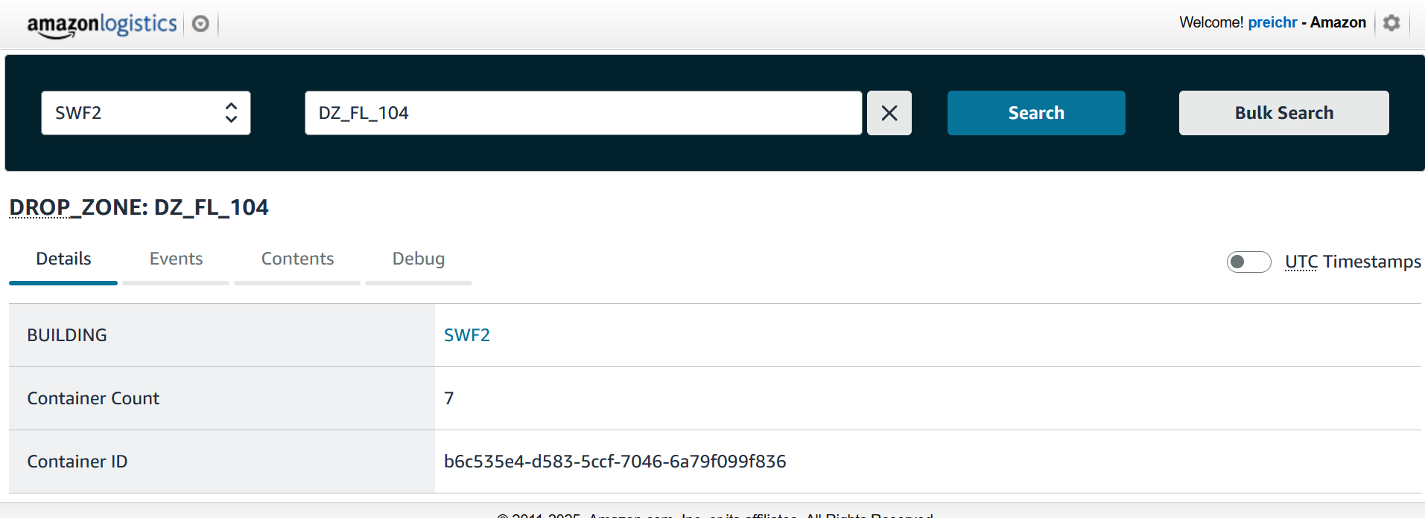
- Navigate to the “Contents” page, click the checkbox to select all, and click “Cleanup”. Don’t worry, this will only apply to empty “ghost pallets”.
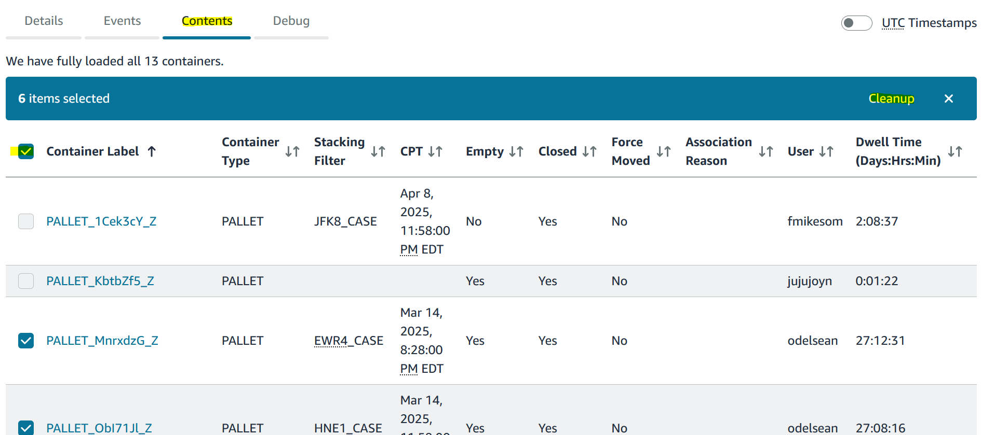
- The webpage will tell you how many ghost containers were cleaned up.
